**CS 419 Compiler**

**Project Form**

**Project Idea:** 1

**Team Members NO#:** 24 Eng : Mai

|  |  |  |  |  |  |
| --- | --- | --- | --- | --- | --- |
| **ID** | **Name** | **Level& Department** | **Section(Dayfrom-to)** | **Role (Lead/Member)** | **Grade** |
| 291000144 | اسلام محمد فايز عبد المطلب | 3 CS |  | Leader |  |
| 201900200 | اياد عبد المنعم عبد الفتاح احمد | 3 CS |  | Member |  |
| 201900152 | اسماعيل سمير عبد الفتاح ابراهيم | 3 CS |  | Member |  |
| 201900799 | مريم اسامه محمد احمد انيس | 3 CS |  | Member |  |
| 201900197 | انور محمد انور حسن | 3 CS |  | Member |  |
| 20180404 | عمرو علاء عبد المنعم حسين | 4 CS |  | Member |  |
| 201900363 | سيف الدين اشرف عبد الله | 3 CS |  | Member |  |

**Regular Expression, Finite automata and Conversion from RegX to NFA, NFA to DFA**

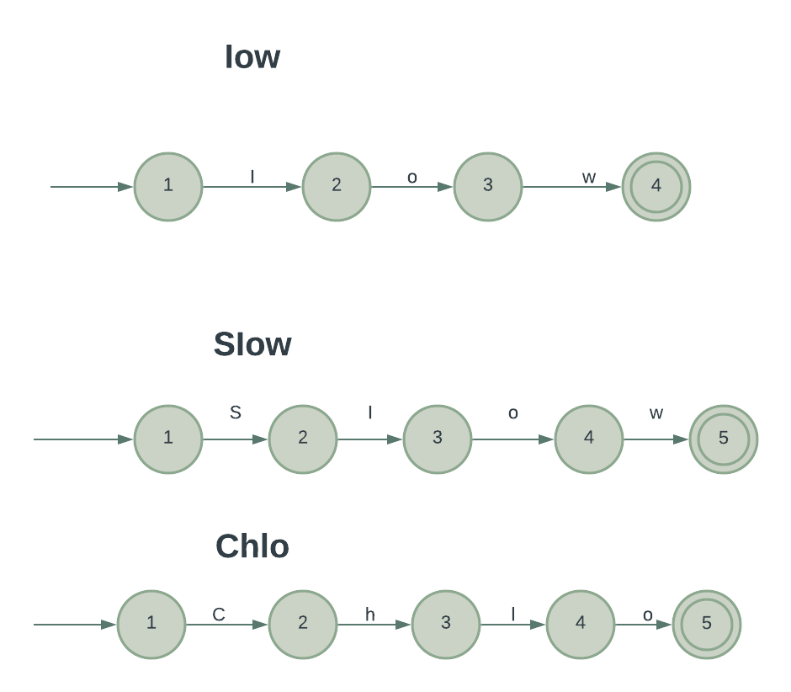

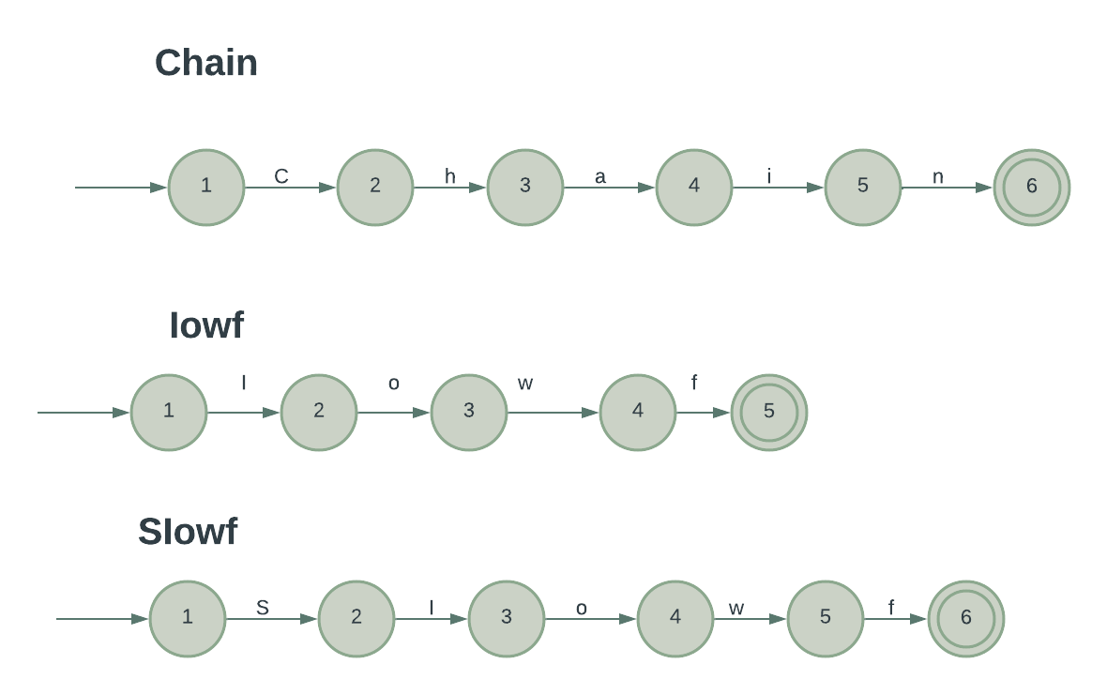

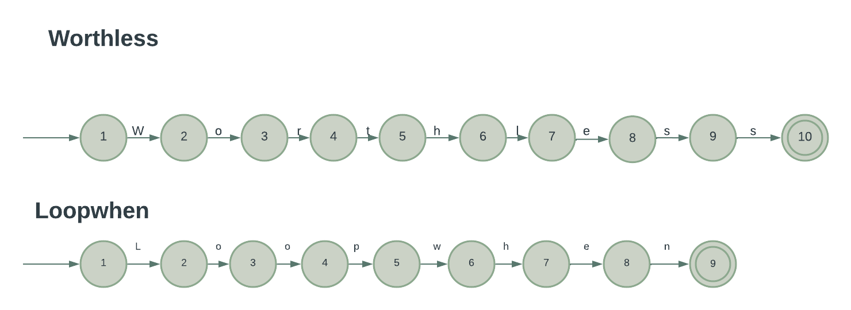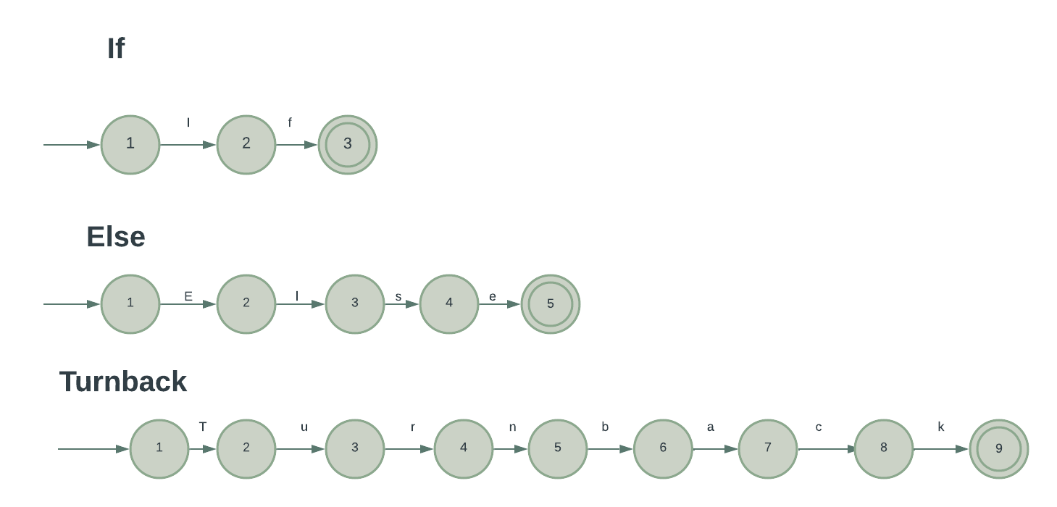

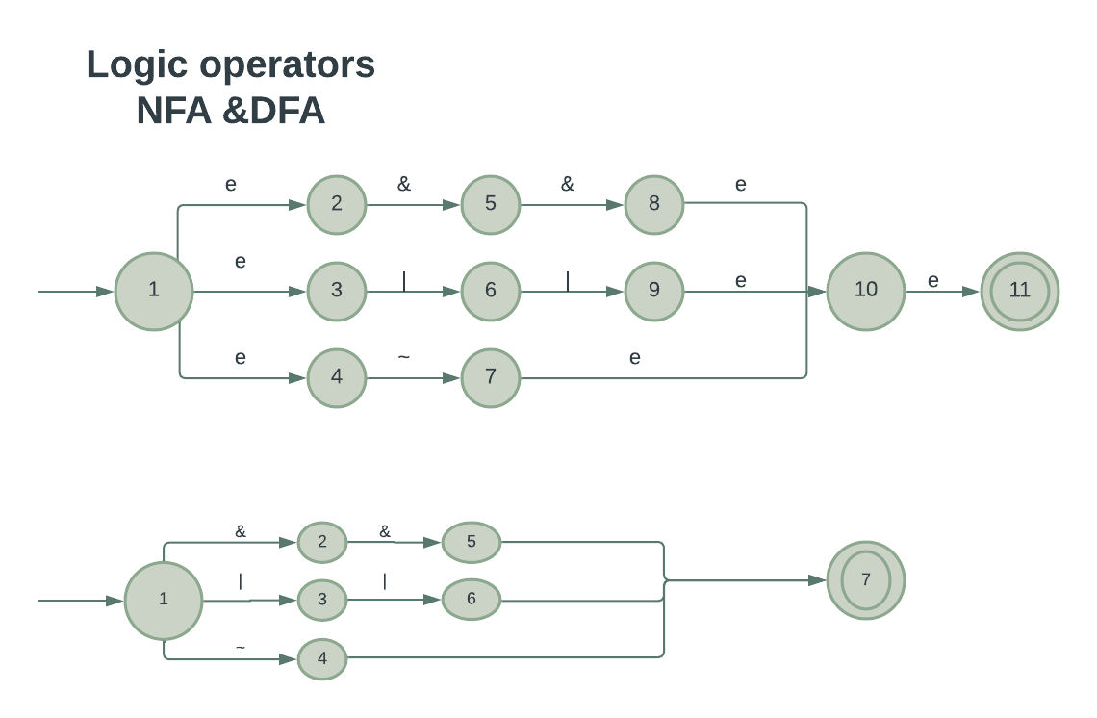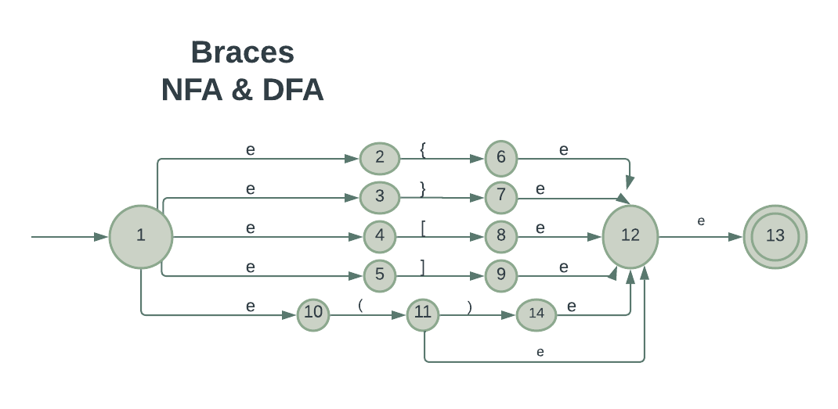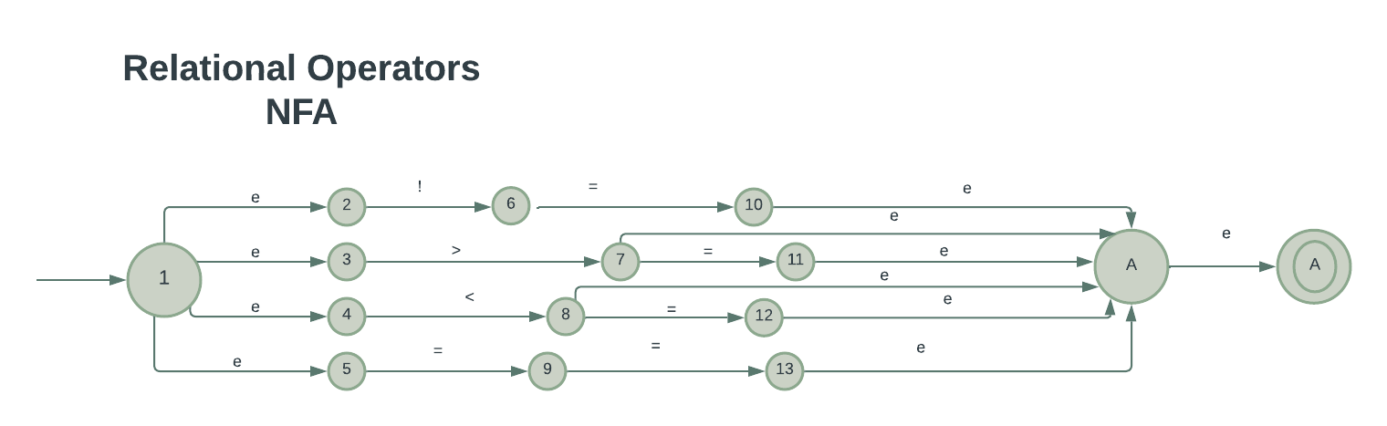

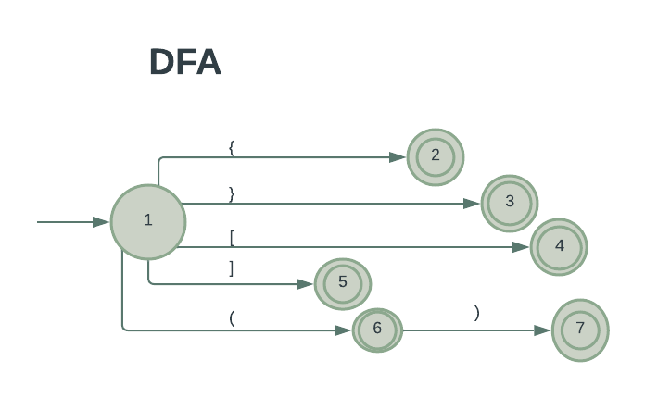

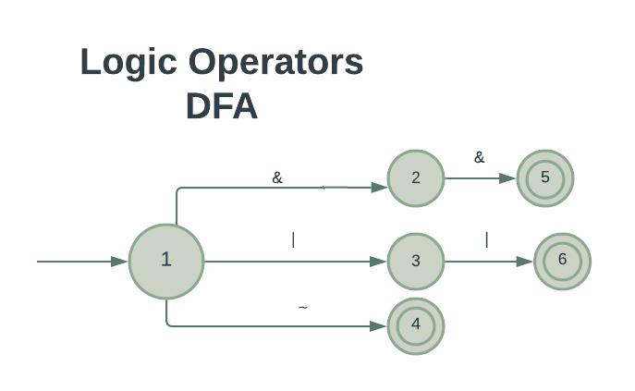

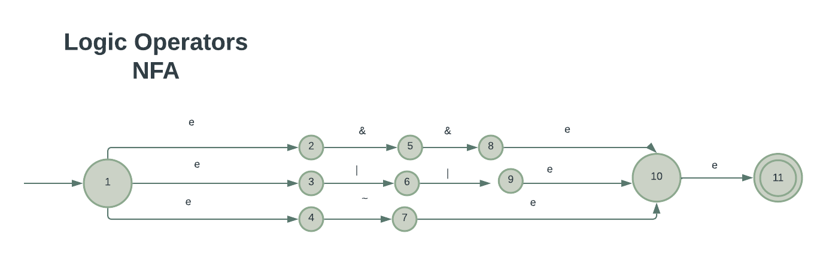

# 

# 

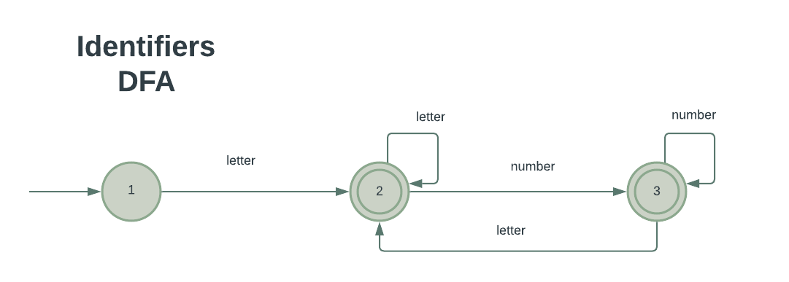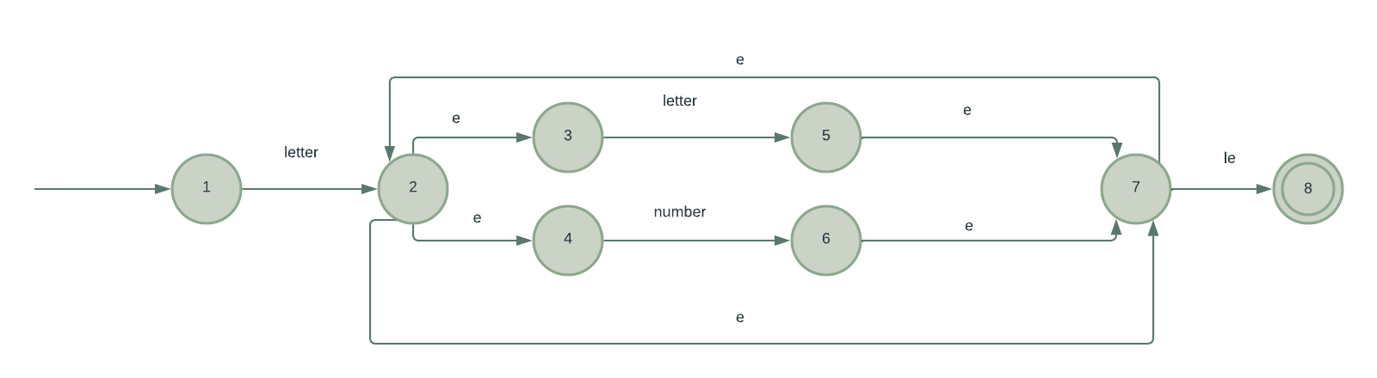

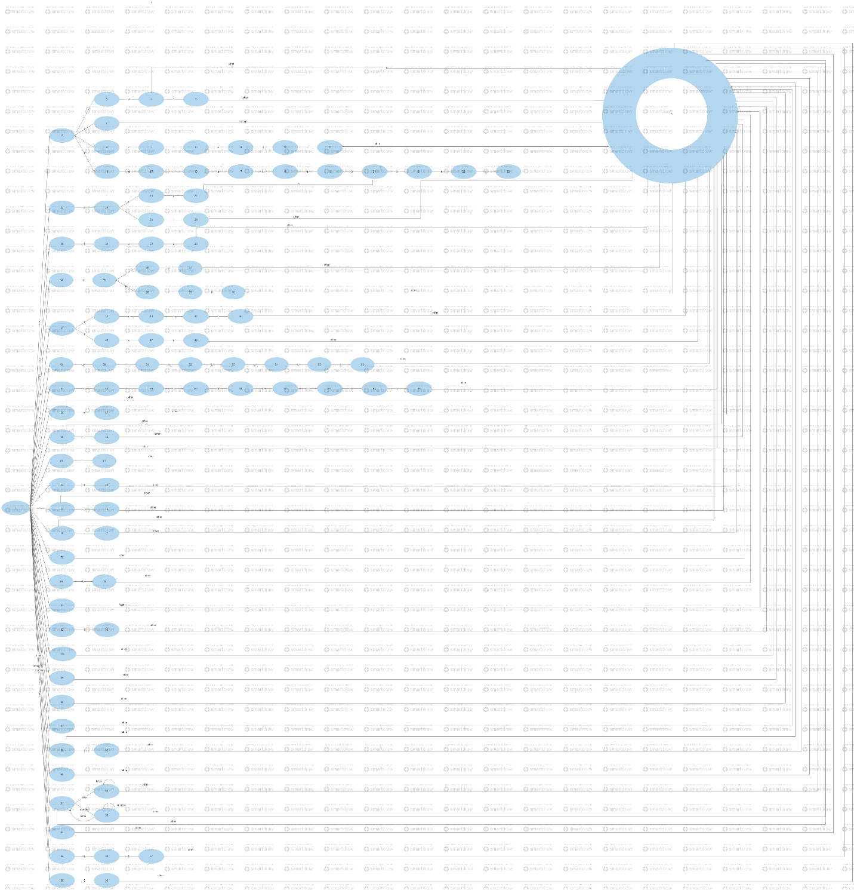

**Parsing Tree**



